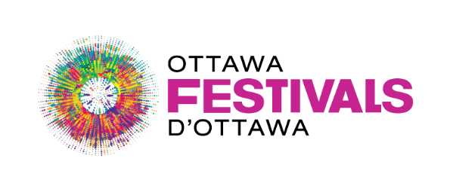

**NextFest Project Summary Template**

Bytown’s 200th Anniversary will celebrate Ottawa’s rich culture and history, artistic expression, and Indigenous heritage and storytelling . Your NextFest project should take this into consideration.

Your project summary must include all of the following. Incomplete project summaries will not be accepted.

1. Please keep in kind the following:

* Estimated capacity of 500–1,000 attendees
* One-day festival format

1. What is your creative, innovative, and unique to Ottawa festival concept ? *(1,000 characters maximum)*
2. How will your project align with Bytown’s 200th anniversary celebrations ? *(1,000 characters maximum)*