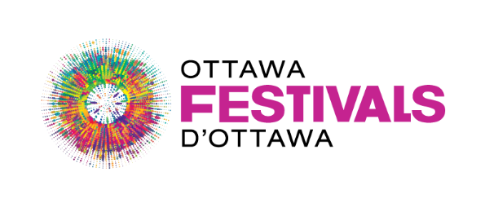
NextFest Project Summary Template
Bytown’s 200th Anniversary will celebrate Ottawa’s rich culture and history, artistic expression, and Indigenous heritage and storytelling . Your NextFest project should take this into consideration.
Your project summary must include all of the following. Incomplete project summaries will not be accepted.
- Please keep in kind the following:
- Estimated capacity of 500–1,000 attendees
- One-day festival format

- What is your creative, innovative, and unique to Ottawa festival concept ? (1,000 characters maximum)

- How will your project align with Bytown’s 200th anniversary celebrations ? (1,000 characters maximum)

